Task 1:
Create a node for a tree and include a constructor (empty).

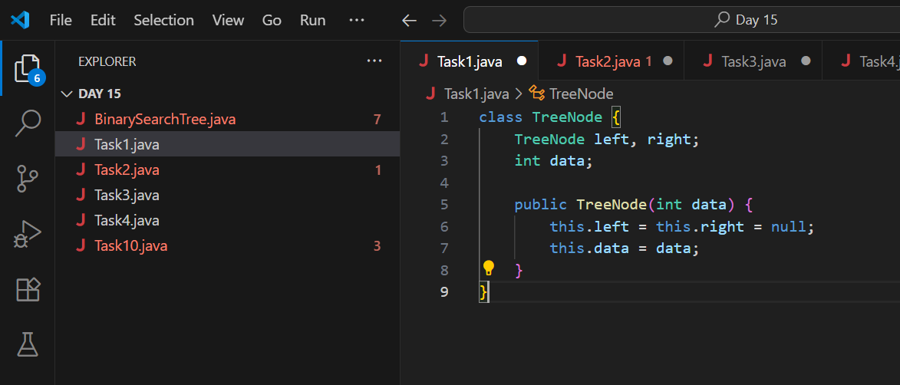

Task 2:

Create a class named Binarty Search tree in which you have 2 insert operations

1 insert —----> for inserting if the tree is empty
1 insert —----> for inserting if the tree has 1 or more nodes

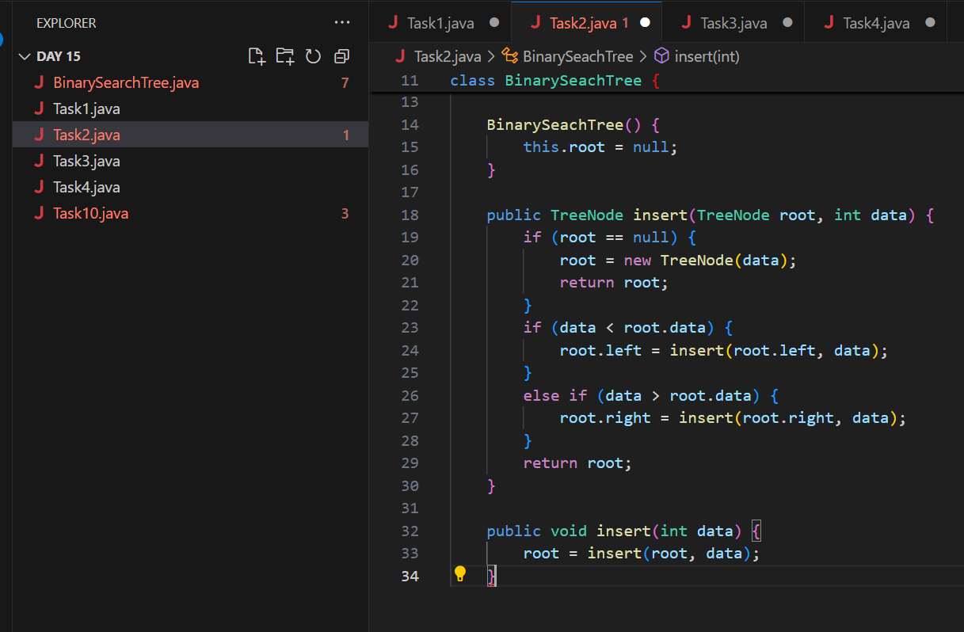
Task 3:

Inorder travel of the above code snippets from task 1 and Task 2

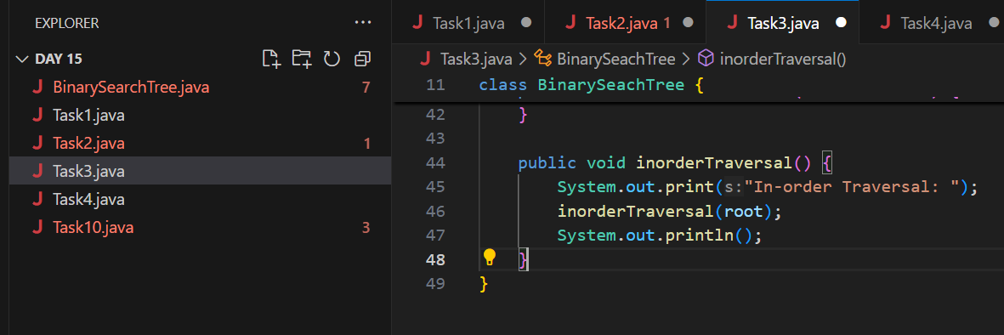

Task 4:

Create a main method Task 1, 2 and 3

And run the code..

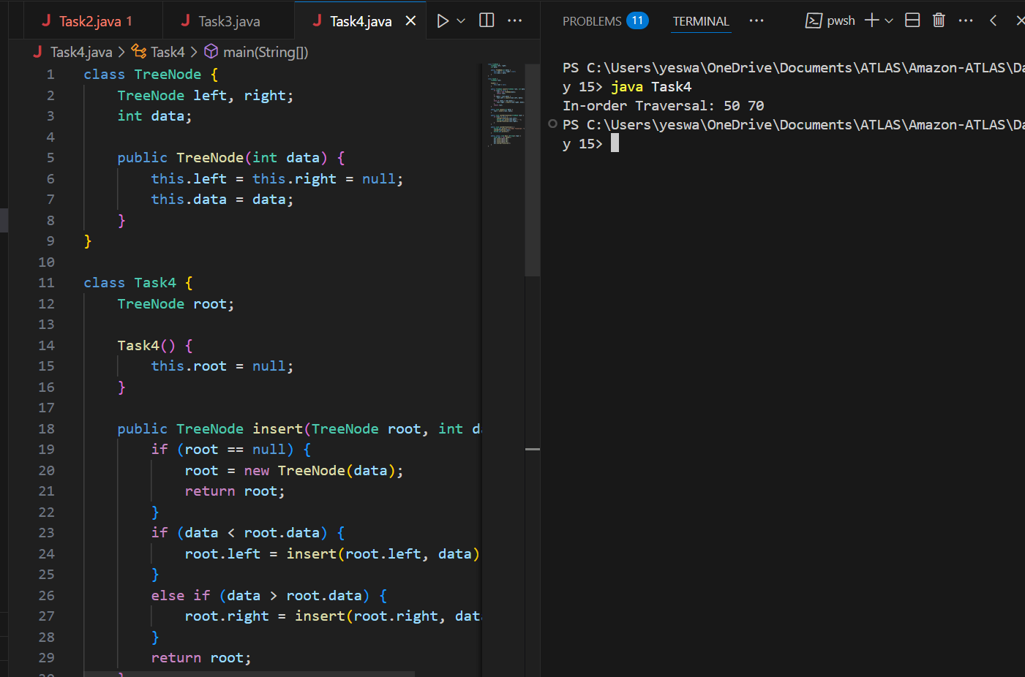

Task 5:
Trees are used in filesystems, HTML, databases etc.
1. Data Storage and Retrieval.
2. Efficient Operations.
3. Artificial Intelligence.
4. Networking.

Task 6:

Create a binary search operation on tree

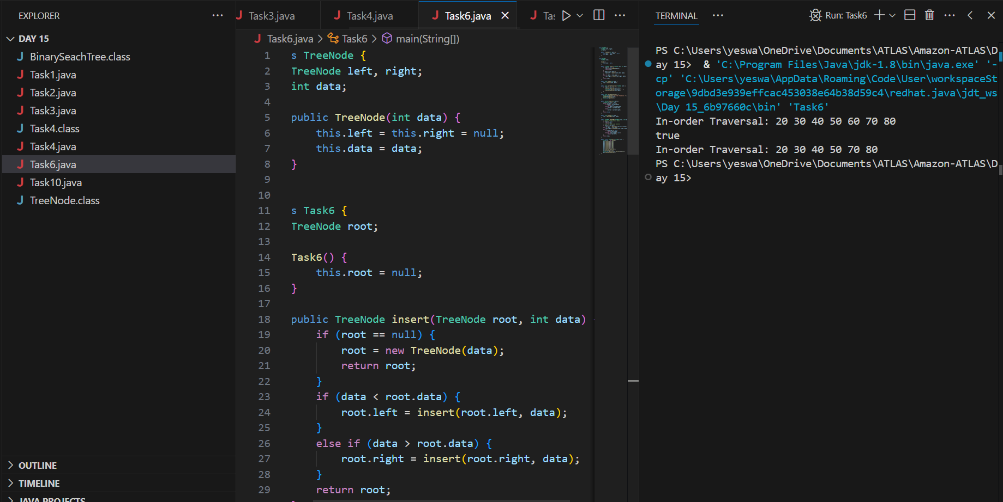

Task 7:

Deletion in BST

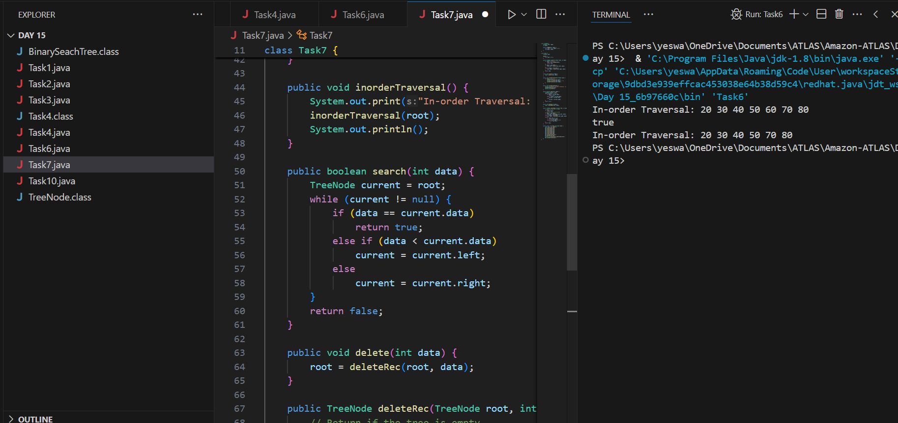

Task 8:

Types of Binary Tree:

- Rooted Binary Tree.
- A rooted binary tree is a tree data structure with a designated root node, where each node can have at most two children, referred to as the left and right child.
- Complete/perfect Binary Tree.
- All levels are filled with 2 child nodes.
- Full/Strict Binary Tree.
- Each node has either 0 children or 2 children.
- Almost complete Binary Tree.
- A binary tree where all levels except possibly the last are completely filled, and on the last level, all nodes are as far left as possible, but some rightmost nodes may be missing.
- Skewed Binary Tree.
- Every node has only one child.

Task 9:

Applications of graphs :

- Navigation systems.
- Computer networks.
- Online websites.
- Ecommerce supply chain.
- Social media platforms.

Task 10:

Types of Graphs:

- Regular Graph.
- Directed graph.
- Undirected graph.
- Cyclic graph.
- Acyclic graph.
- Complete graph.
- Connected graph.
- Disconnected graph.
- Weighted graph.
- Unweighted graph.
- Null graph.

